Some Options for Non-MARC Descriptive Metadata
Jenn Riley
TS Cataloging Division Meeting
12/9/2008

MARCXML
http://www.loc.gov/standards/marcxml/

<?xml version="1.0" encoding="UTF-8"?>
<collection xmlns="http://www.loc.gov/MARC21/slim">
<record>
<leader>01142cam 2200301 a 4500</leader>
<controlfield tag="001"> 92005291 </controlfield>
<controlfield tag="003">DLC</controlfield>
<controlfield tag="005">19930521155141.9</controlfield>
<controlfield tag="008">920219s1993 caua j 000 0 eng </controlfield>
<datafield tag="010" ind1=" " ind2=" ">
<subfield code="a"> 92005291 </subfield>
</datafield>
<datafield tag="020" ind1=" " ind2=" ">
<subfield code="a">0152038655 :</subfield>
<subfield code="c">$15.95</subfield>
</datafield>
<datafield tag="040" ind1=" " ind2=" ">
<subfield code="a">DLC</subfield>
<subfield code="c">DLC</subfield>
<subfield code="d">DLC</subfield>
</datafield>
<datafield tag="042" ind1=" " ind2=" ">
<subfield code="a">lcac</subfield>
</datafield>
<datafield tag="050" ind1="0" ind2="0">
<subfield code="a">PS3537.A618</subfield>
<subfield code="b">A88 1993</subfield>
</datafield>
<datafield tag="082" ind1="0" ind2="0">
<subfield code="a">811/.52</subfield>
<subfield code="2">20</subfield>
</datafield>
<datafield tag="100" ind1="1" ind2=" ">
<subfield code="a">Sandburg, Carl,</subfield>
<subfield code="d">1878-1967.</subfield>
</datafield>
<datafield tag="245" ind1="1" ind2="0">
<subfield code="a">Arithmetic /</subfield>
<subfield code="c">Carl Sandburg ; illustrated as an anamorphic adventure by Ted Rand.</subfield>
</datafield>
<datafield tag="250" ind1=" " ind2=" ">
<subfield code="a">1st ed.</subfield>
</datafield>
<datafield tag="260" ind1=" " ind2=" ">
<subfield code="a">San Diego :</subfield>
<subfield code="b">Harcourt Brace Jovanovich,</subfield>
<subfield code="c">c1993.</subfield>
</datafield>
<datafield tag="300" ind1=" " ind2=" ">
<subfield code="a">1 v. (unpaged) :</subfield>
<subfield code="b">ill. (some col.) ;</subfield>
<subfield code="c">26 cm.</subfield>
</datafield>
<datafield tag="500" ind1=" " ind2=" ">
<subfield code="a">One Mylar sheet included in pocket.</subfield>
</datafield>
<datafield tag="520" ind1=" " ind2=" ">
<subfield code="a">A poem about numbers and their characteristics. Features anamorphic, or distorted, drawings which can be restored to normal by viewing from a particular angle or by viewing the image's reflection in the provided Mylar cone.</subfield>
</datafield>
<datafield tag="650" ind1=" " ind2="0">
<subfield code="a">Arithmetic</subfield>
<subfield code="x">Juvenile poetry.</subfield>
</datafield>
<datafield tag="650" ind1=" " ind2="0">
<subfield code="a">Children's poetry, American.</subfield>
</datafield>
<datafield tag="650" ind1=" " ind2="1">
<subfield code="a">Arithmetic</subfield>
<subfield code="x">Poetry.</subfield>
</datafield>
<datafield tag="650" ind1=" " ind2="1">
<subfield code="a">American poetry.</subfield>
</datafield>
<datafield tag="650" ind1=" " ind2="1">
<subfield code="a">Visual perception.</subfield>
</datafield>
<datafield tag="700" ind1="1" ind2=" ">
<subfield code="a">Rand, Ted,</subfield>
<subfield code="e">ill.</subfield>
</datafield>
</record>
</collection>
MODS
http://www.loc.gov/standards/mods/

http://www.dlfaquifer.org/search/item/US-Capitol-interiors-Senate-chamber-in/oai%253Alcoa1%252Eloc%252Egov%253Aloc%252Epnp%252Fthc%252E5a37634

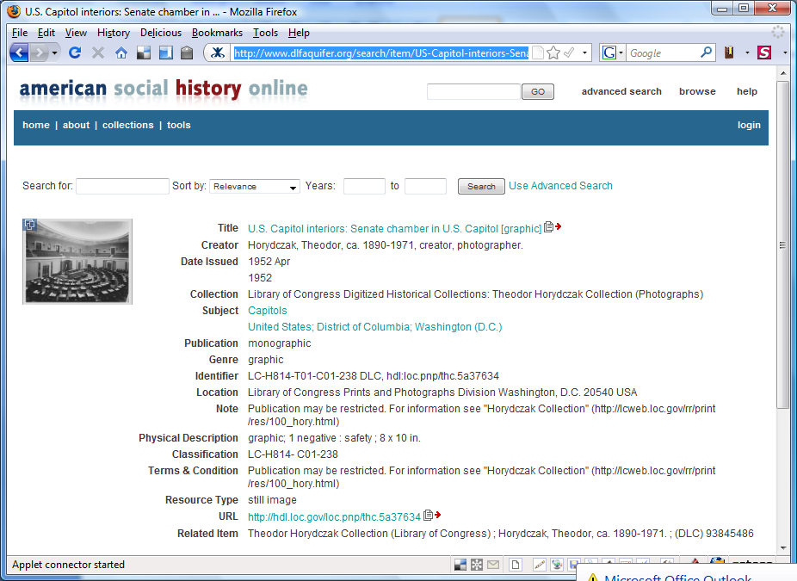

<mods xmlns="http://www.loc.gov/mods/v3" xmlns:xlink="http://www.w3.org/1999/xlink">
<titleInfo>
<title>U.S. Capitol interiors</title>
<partName>Senate chamber in U.S. Capitol [graphic]</partName>
</titleInfo>
<name type="personal">
<namePart>Horydczak, Theodor</namePart>
<namePart type="date">ca. 1890-1971</namePart>
<role>
<roleTerm authority="marcrelator" type="text">creator</roleTerm>
</role>
<role>
<roleTerm type="text">photographer.</roleTerm>
</role>
</name>
<typeOfResource>still image</typeOfResource>
<genre authority="marc">graphic</genre>
<originInfo>
<place>
<placeTerm type="code" authority="marccountry">xx</placeTerm>
</place>
<dateIssued>1952 Apr</dateIssued>
<dateIssued encoding="marc">1952</dateIssued>
<issuance>monographic</issuance>
</originInfo>
<physicalDescription>
<form authority="gmd">graphic</form>
<extent>1 negative : safety ; 8 x 10 in.</extent>
</physicalDescription>
<note>Publication may be restricted. For information see "Horydczak Collection"
(http://lcweb.loc.gov/rr/print/res/100_hory.html)</note>
<subject authority="lctgm">
<topic>Capitols</topic>
</subject>
<subject>
<hierarchicalGeographic>
<country>United States</country>
<state>District of Columbia</state>
<city>Washington (D.C.)</city>
</hierarchicalGeographic>
</subject>
<classification authority="lcc">LC-H814- C01-238</classification>
<relatedItem type="host">
<titleInfo>
<title>Theodor Horydczak Collection (Library of Congress)</title>
</titleInfo>
<name>
<namePart>Horydczak, Theodor, ca. 1890-1971.</namePart>
</name>
<identifier type="local">(DLC) 93845486</identifier>
</relatedItem>
<relatedItem type="host">
<titleInfo type="uniform" authority="dlfaqcoll">
<title>Library of Congress Digitized Historical Collections: Theodor Horydczak
Collection (Photographs)</title>
</titleInfo>
</relatedItem>
<identifier type="stock number">LC-H814-T01-C01-238 DLC</identifier>
<identifier type="hdl">hdl:loc.pnp/thc.5a37634</identifier>
<location>
<url displayLabel="intermediary roll film">http://hdl.loc.gov/loc.pnp/thc.5a37634</url>
<url access="preview"
>http://quod.lib.umich.edu/m/mods/thumbs/thc/oai_3Alcoa1.loc.gov_3Aloc.pnp_2Fthc.5a37634.png</url>
</location>
<location>
<physicalLocation>Library of Congress Prints and Photographs Division Washington, D.C. 20540
USA</physicalLocation>
</location>
<accessCondition>Publication may be restricted. For information see "Horydczak Collection"
(http://lcweb.loc.gov/rr/print/res/100_hory.html)</accessCondition>
<recordInfo>
<recordContentSource authority="marcorg">DLC</recordContentSource>
<recordCreationDate encoding="marc">930818</recordCreationDate>
<recordChangeDate encoding="iso8601">20060318181537.0</recordChangeDate>
<recordChangeDate encoding="iso8601">20060318181537.0</recordChangeDate>
<recordIdentifier>thc1995010875/PP</recordIdentifier>
</recordInfo>
</mods>
Simple Dublin Core
http://www.dublincore.org/documents/dces/

http://www.open-video.org/details.php?videoid=6136

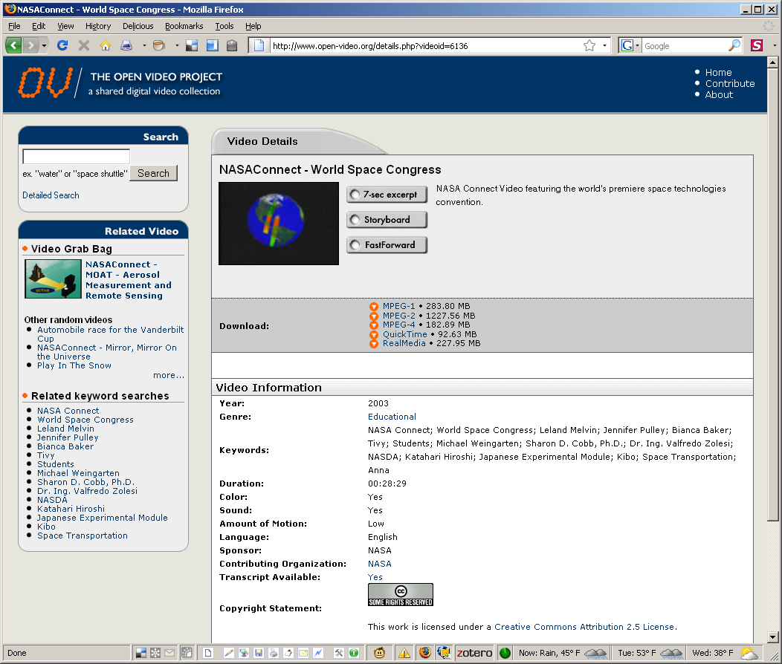

<?xml version="1.0" encoding="UTF-8"?>
<dc xmlns="http://purl.org/dc/elements/1.1/" xmlns:xsi="http://www.w3.org/2001/XMLSchema-instance"
xsi:schemaLocation="http://purl.org/dc/elements/1.1/ http://www.openarchives.org/OAI/2.0/oai_dc.xsd">
<title>NASAConnect - World Space Congress</title>
<description>NASA Connect Video featuring the world's premiere space technologies
convention.</description>
<subject>NASA Connect; World Space Congress; Leland Melvin; Jennifer Pulley; Bianca Baker; Tivy;
Students; Michael Weingarten; Sharon D. Cobb, Ph.D.; Dr. Ing. Valfredo Zolesi; NASDA;
Katahari Hiroshi; Japanese Experimental Module; Kibo; Space Transportation; Anna </subject>
<creator>NASA</creator>
<date>2003-10-27</date>
<source>Open Video</source>
<contributor>NASA</contributor>
<language>English</language>
<coverage>Educational</coverage>
<rights>&lt;!--Creative Commons License--&gt;&lt;a rel="license"
href="http://creativecommons.org/licenses/by/2.5/"&gt;&lt;img alt="Creative Commons
License" border="0"
src="http://creativecommons.org/images/public/somerights20.png"/&gt;&lt;/a&gt;&lt;br/&gt;This
work is licensed under a &lt;a rel="license"
href="http://creativecommons.org/licenses/by/2.5/"&gt;Creative Commons Attribution 2.5
License&lt;/a&gt;.&lt;!--/Creative Commons License--&gt;&lt;!--
&lt;rdf:RDF xmlns="http://web.resource.org/cc/"
xmlns:dc="http://purl.org/dc/elements/1.1/"
xmlns:rdf="http://www.w3.org/1999/02/22-rdf-syntax-ns#"&gt; &lt;Work
rdf:about=""&gt; &lt;license
rdf:resource="http://creativecommons.org/licenses/by/2.5/" /&gt; &lt;/Work&gt;
&lt;License
rdf:about="http://creativecommons.org/licenses/by/2.5/"&gt;&lt;permits
rdf:resource="http://web.resource.org/cc/Reproduction"/&gt;&lt;permits
rdf:resource="http://web.resource.org/cc/Distribution"/&gt;&lt;requires
rdf:resource="http://web.resource.org/cc/Notice"/&gt;&lt;requires
rdf:resource="http://web.resource.org/cc/Attribution"/&gt;&lt;permits
rdf:resource="http://web.resource.org/cc/DerivativeWorks"/&gt;&lt;/License&gt;&lt;/rdf:RDF&gt;
--&gt;</rights>
<publisher>Open Video</publisher>
<type>video</type>
<identifier>http://www.open-video.org/details.php?videoid=6136</identifier>
</dc>
Qualified Dublin Core
http://www.dublincore.org/documents/dcmi-terms/

http://images.library.uiuc.edu:8081/u?/maps,261

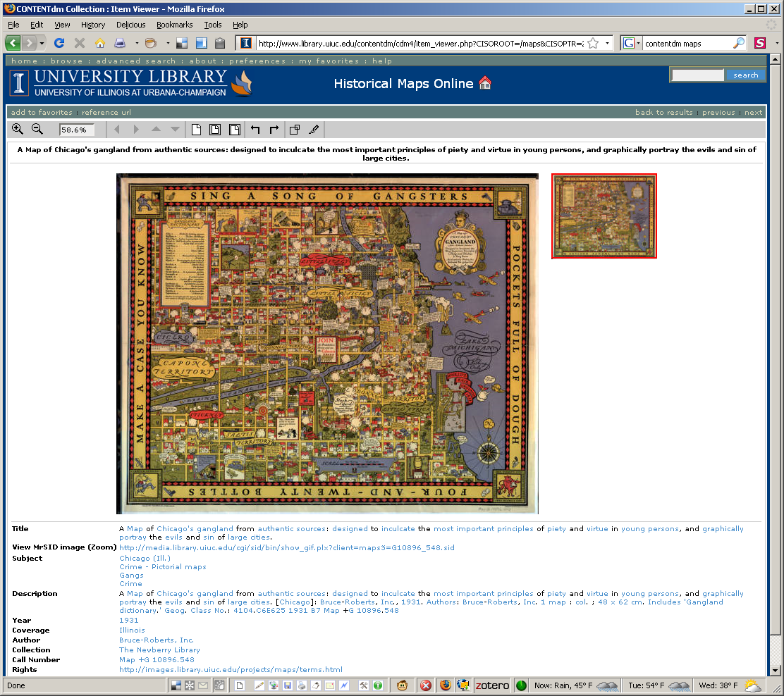

<?xml version="1.0" encoding="UTF-8"?>
<qdc:qualifieddc xmlns:qdc="http://epubs.cclrc.ac.uk/xmlns/qdc/"
xmlns:dc="http://purl.org/dc/elements/1.1/" xmlns:dcterms="http://purl.org/dc/terms/"
xmlns:xsi="http://www.w3.org/2001/XMLSchema-instance"
xsi:schemaLocation="http://epubs.cclrc.ac.uk/xmlns/qdc/
http://epubs.cclrc.ac.uk/xsd/qdc.xsd">
<dc:title>A Map of Chicago's gangland from authentic sources: designed to inculcate the most
important principles of piety and virtue in young persons, and graphically portray the evils and
sin of large cities.</dc:title>
<dcterms:alternative/>
<dc:subject>Chicago (Ill.); Crime - Pictorial maps; Gangs; Crime;</dc:subject>
<dc:description>A Map of Chicago's gangland from authentic sources: designed to inculcate the most
important principles of piety and virtue in young persons, and graphically portray the evils and
sin of large cities. [Chicago]: Bruce-Roberts, Inc., 1931. Authors: Bruce-Roberts, Inc. 1 map :
col. ; 48 x 62 cm. Includes 'Gangland dictionary.' Geog. Class No.: 4104.C6E625 1931 B7 Map +G
10896.548</dc:description>
<dc:description/>
<dc:date/>
<dcterms:temporal>1931</dcterms:temporal>
<dcterms:spatial>Illinois</dcterms:spatial>
<dc:creator>Bruce-Roberts, Inc.</dc:creator>
<dc:contributor/>
<dc:publisher>The Newberry Library</dc:publisher>
<dc:identifier>Map +G 10896.548</dc:identifier>
<dc:format/>
<dc:source/>
<dc:language/>
<dc:rights>http://images.library.uiuc.edu/projects/maps/terms.html</dc:rights>
<dc:identifier>http://images.library.uiuc.edu:8081/u?/maps,261</dc:identifier>
</qdc:qualifieddc>

