FRBR Group 1 Entities: Products of intellectual & artistic endeavor

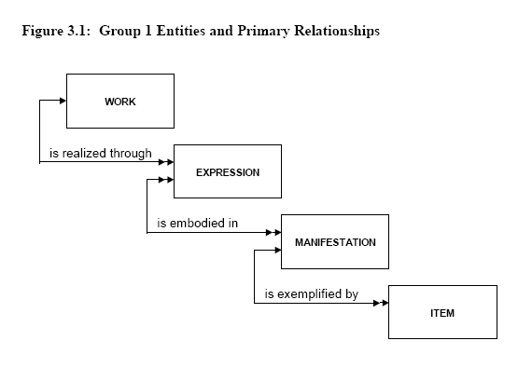

Work attributes
title of the work
form of work
date of the work
other distinguishing characteristic
intended termination
intended audience
context for the work
medium of performance (musical work)
numeric designation (musical work)
key (musical work)
coordinates (cartographic work)
equinox (cartographic work)

Manifestation attributes
title of the manifestation
statement of responsibility
edition/issue designation
place of publication/distribution
publisher/distributor
date of publication/distribution
fabricator/manufacturer
series statement
form of carrier
extent of the carrier
physical medium
capture mode
dimensions of the carrier
manifestation identifier
source for acquisition/access authorization
terms of availability
access restrictions on the manifestation
typeface (printed book)
type size (printed book)
foliation (hand-printed book)
collation (hand-printed book)
publication status (serial)
numbering (serial)
playing speed (sound recording)
groove width (sound recording)
kind of cutting (sound recording)
tape configuration (sound recording)
kind of sound (sound recording)
special reproduction characteristic (sound recording)
colour (image)
reduction ratio (microform)
polarity (microform or visual projection)
generation (microform or visual projection)
presentation format (visual projection)
system requirements (electronic resource)
file characteristics (electronic resource)
mode of access (remote access electronic resource)
access address (remote access electronic resource)

Expression attributes
title of the expression
form of expression
date of expression
language of expression
other distinguishing characteristic
extensibility of expression
revisability of expression
extent of the expression
summarization of content
context for the expression
critical response to the expression
use restrictions on the expression
sequencing pattern (serial)
expected regularity of issue (serial)
expected frequency of issue (serial)
type of score (musical notation)
medium of performance (musical notation or recorded sound)
scale (cartographic image/object)
projection (cartographic image/object)
presentation technique (cartographic image/object)
representation of relief (cartographic image/object)
geodetic, grid, and vertical measurement (cartographic image/object)
recording technique (remote sensing image)
special characteristic (remote sensing image)
technique (graphic or projected image)

Item attributes
item identifier
fingerprint
provenance of the item
marks/inscriptions
exhibition history
condition of the item
treatment history
scheduled treatment
access restrictions on the item
Note: The attributes defined for the purposes of this study do not include those associated with transactions of an ephemeral nature such as the circulation or processing of an item.

FRBR Group 2 Entities: Those responsible for intellectual & artistic content
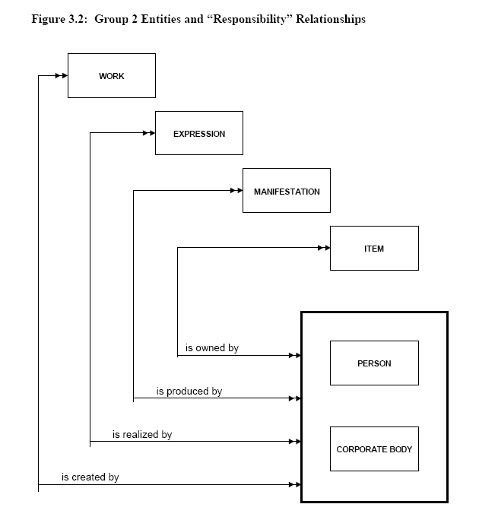

Person attributes
name of person
dates of person
title of person
other designation associated with the person
Corporate body attributes
name of the corporate body
number associated with the corporate body
place associated with the corporate body
date associated with the corporate body
other designation associated with the corporate body

FRBR Group 3 Entities: Subjects of works
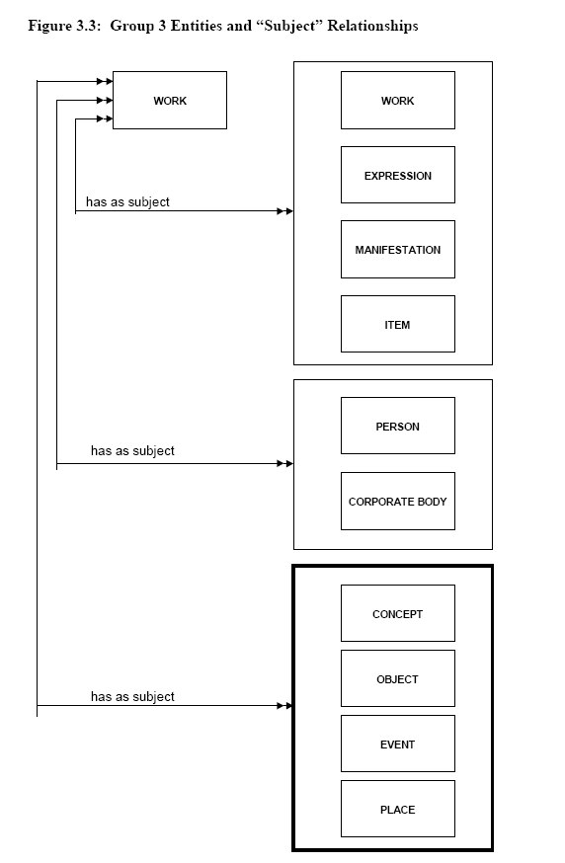

Concept attributes
term for the concept

Event attributes
term for the event
Object attributes
term for the object

Place attributes
term for the place

Examples of Work/Expression/Manifestation
w₁ Harry Lindgren's Geometric dissections
e₁ original text entitled Geometric dissections
m₁ the book published in 1964 by Van Nostrand
e₂ revised text entitled Recreational problems in geometric dissections ....
m₁ the book published in 1972 by Dover

w₁ J. S. Bach's Six suites for unaccompanied cello
e₁ performances by Janos Starker recorded in 1963 and 1965
m₁ recordings released on 33 1/3 rpm sound discs in 1965 by Mercury
m₂ recordings re-released on compact disc in 1991 by Mercury
e₂ performances by Yo-Yo Ma recorded in 1983
m₁ recordings released on 33 1/3 rpm sound discs in 1983 by CBS Records
m₂ recordings re-released on compact disc in 1992 by CBS Records

w₁ Jean Jolivet's Vraie description des Gaules....
e₁ the cartographer's original rendering
m₁ the map issued in 1570
m₂ a facsimile reproduction published in 1974 by Hier et demain

w₁ The Wall Street Journal
e₁ the Eastern edition
m₁ the print format of the Eastern edition
m₂ the microfilm of the Eastern edition
e₂ the Western edition
m₁ the print format of the Western edition
m₂ the microfilm of the Western edition

Some Suggested Readings
Antelman, Kristin. Identifying the serial work as a bibliographic entity. Library Resources & Technical Services 48, no. 4 (October 2004): 238-255. http://eprints.rclis.org/archive/00002604/01/identifying_LRTS.pdf
Ayres, Marie-Louise, Kerry Kilner, Kent Fitch, and Annette Scarvell. “Report on the Successful AustLit: Australian Literature Gateway Implementation of the FRBR and INDECS Event Models, and Implication for Other FRBR Implementations.” 68th IFLA Council and General Conference, Glasgow, August 18-24, 2002. http://www.ifla.org/IV/ifla68/papers/054-133e.pdf
Bennett, Rick, Brian F. Lavoie, and Edward T. O'Neill. “The Concept of a Work in WorldCat: an Application of FRBR.” Library Collections, Acquisitions, & Technical Services 27 (2003): 45-59.
Bowen, Jennifer. “FRBR: Coming Soon to Your Library?” Library Resources & Technical Services 49, no. 3 (July 2005): 175-188.
Carlyle, Allyson. “Understanding FRBR as a Conceptual Model: FRBR and the Bibliographic Universe.” Library Resources & Technical Services 50, no. 4 (October 2006): 264-273.
Delsey, Tom. “Functional Analysis of the MARC21 Bibliographic and Holdings Formats.” Library of Congress Network Development and MARC Standards Office (June 23, 2004). http://www.loc.gov/marc/marc-functional-analysis/functional-analysis.html
Hegna, Knut, and Eeva Murtomaa. "Data Mining MARC to Find: FRBR?"68th IFLA Council and General Conference, Glasgow, August 18-24, 2002. http://www.ifla.org/IV/ifla68/papers/053-133e.pdf
Hickey, Thomas B., Edward T. O'Neill, and Jenny Toves. "Experiments With the IFLA Functional Requirements for Bibliographic Records (FRBR)." D-Lib Magazine 8, no. 9 (2002). http://www.dlib.org/dlib/september02/hickey/09hickey.html.
IFLA Study Group on the Functional Requirements for Bibliographic Records. 1998. Functional Requirements for Bibliographic Records. Munich: K.G. Saur. http://www.ifla.org/VII/s13/frbr/frbr.pdf.
Jonsson, Gunilla. "The Basis for a Record in Major Cataloguing Codes and the Relation to FRBR."68th IFLA Council and General Conference, Glasgow, August 18-24, 2002. http://www.ifla.org/IV/ifla68/papers/052-133e.pdf.
Le Boeuf, Patrick. "Brave New FRBR World."IFLA Meeting of Experts on an International Cataloging Code, Frankfurt July 2003. http://www.ddb.de/news/pdf/papers_leboeuf.pdf.
O’Neill, Edward T. "FRBR: Functional Requirements for Bibliographic Records: Application of the Entity-Relationship Model to Humphry Clinker." Library Resources & Technical Services 46, no. 4 (2002): 150-159.
Riva, Pat. "Mapping MARC 21 Linking Entry Fields to FRBR and Tillett's Taxonomy of Bibliographic Relationships." Library Resources and Technical Services 48, no. 2 (2004): 130-143.
Yee, Martha M. FRBRization: A Method for Turning Online Public Finding Lists into Online Public Catalogs. Information Technology and Libraries, vol. 24, No. 3 (2005): 77-95. Postprint available at: <http://repositories.cdlib.org/postprints/715>.
Zumer, Maja, and Gerhard J. A. Riesthuis. "Consequences of Implementing FRBR: Are We Ready to Open Pandora's Box?" Knowledge Organization 29, no. 2 (2002): 78-86.

